Fastest Car per Brand Analysis

This analysis identifies the fastest accelerating car (measured by 0–60 MPH time) from each car manufacturer. Using data grouped by 'Car Make', the car with the lowest 0–60 MPH time in each group was selected. The resulting cars were sorted and visualized to highlight acceleration performance across brands.

Key Insights:

* - The analysis uses grouping and filtering techniques in pandas.
* - Fastest car per brand is selected using the minimum 0–60 MPH time.
* - A bar plot visualizes how each brand’s quickest car performs in terms of acceleration.

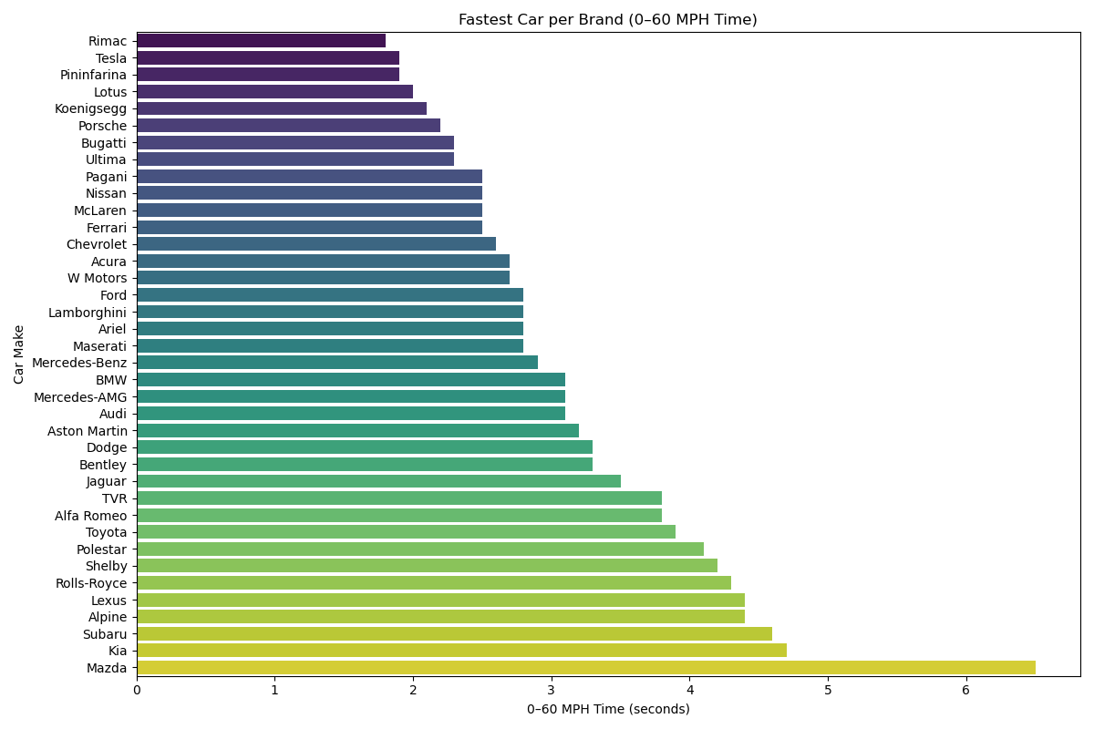

Figure: Fastest car per brand based on 0–60 MPH time.